|  |  |
| --- | --- |
| \\VFILERDPI\DPI-Home\OBRIENR2\My Documents\Downloads\PP logo.jpg | Central Coast Council Logo |
| **COUNCIL ASSESSMENT REPORT – MODIFICATION APPLICATION**  HUNTER AND CENTRAL COAST REGIONAL PLANNING PANEL | |

|  |  |
| --- | --- |
| PANEL REFERENCE & DA NUMBER | PPSHCC – 273 – DA/882/2021/A  PAN - 394766 CNR-64982 |
| PROPOSAL | Section 4.55(2) modification to Seniors Development in 2 stages comprising, construction of a residential aged care facility (RACF) and independent living units (ILU’s) with associated on-site support services and communal facilities, parking, landscaping, demolition and other ancillary uses and works under SEPP (Housing for Seniors or People with a Disability) 2004. |
| ADDRESS | 19-21 Bias Avenue, Lot 524, DP.823143 and 1 Harbour Street, Lot 16 DP.240129, Bateau Bay |
| APPLICANT | Uniting Church in Australia Property Trust (NSW) C/- Gyde Consulting |
| OWNER | Uniting Church in Australia Property Trust NSW |
| MOD LODGEMENT DATE | 24 Jan 2024 |
| ORIGINAL DA DETERMINATION DATE | 30 November 2022 |
| APPLICATION TYPE | Modification under S4.55(2) & Integrated Development |
| REGIONALLY SIGNIFICANT CRITERIA | Modification under S4.55(2) to Development Application with CIV > $30M as specified under Section 275(2) EPAR 2021 |
| CIV | $134,490,548 (excluding GST) |
| CLAUSE 4.6 REQUESTS | Original Consent included a Clause 4.6 variation to Clause 5 Part 1 Schedule 3 of SEPP (Housing for Seniors or People with a Disability) 2004 |
| KEY SEPP/LEP | * *State Environmental Planning Policy (SEPP) (Resilience and Hazards) 2021* * *SEPP (Transport and Infrastructure) 2021* * *SEPP (Planning Systems) 2021* * *SEPP No.65 - Design Quality of Residential Apartment Development* * *SEPP (Building Sustainability Index: BASIX)* * *SEPP (Biodiversity and Conservation) 2021* * *SEPP* *(Housing for Seniors or People with a Disability) 2004* * *SEPP (Housing) 2021* * *SEPP (Industry and Employment) 2021* * *Central Coast Local Environmental Plan 2022* * *Wyong Local Environmental Plan 2013* |
| TOTAL & UNIQUE SUBMISSIONS | 2 unique submissions |
| DOCUMENTS SUBMITTED FOR CONSIDERATION | Architectural Plans, Landscape Plans and supporting documentation |
| SPECIAL INFRASTRUCTURE CONTRIBUTIONS (S7.24) | No |
| RECOMMENDATION | Approval |
| DRAFT CONDITIONS TO APPLICANT | No |
| SCHEDULED MEETING DATE | 25 September 2024 |
| PLAN VERSIONS | 10 November 2023 Version F & 1 August 2024 Version E |
| PREPARED BY | Principal Development Planner – S Pendergast |
| DATE OF REPORT | 25 September 2024 |

**EXECUTIVE SUMMARY**

The modification application has been lodged pursuant to section 4.55(2) of the *Environmental Planning and Assessment Act 1979* (‘EP&A Act’) and seeks consent for amendments to a consent granted under DA/882/2021 approved by the Panel on 30 November 2022. This consent approved a Seniors housing development in 2 stages comprising, construction of a residential aged care facility (RACF) and independent living units (ILU’s) with associated on-site support services and communal facilities, parking, landscaping, demolition and other ancillary uses and works under SEPP (Housing for Seniors or People with a Disability) 2004 at 19-21 Bias Avenue, and 1 Harbour Street, Bateau Bay (‘the site’).

The application is referred to the Hunter and Central Coast Regional Planning Panel (‘the Panel’) and is for a modification under S4.55(2) to Development Application with CIV > $30M as specified under Section 275(2) EPAR 2021. The modification application includes the relevant information required by Clause 100 of the *Environmental Planning and Assessment Regulation 2021* (‘2021 EP&A Regulation’).

The proposed modification relates to the Stage 1 works under the original consent comprising Buildings 2, 3 and 5. The modifications include the reconfiguration of the unit floor plates and layouts for more efficiencies and improved functionality; minor alterations to the external facades and reductions in built form along the eastern boundary; minor alterations to, and reconfiguration of, parking layout; alterations to the roof form to support an adjustment to mechanical plant; and various other minor amendments including planting and fencing. The proposed modification is considered to satisfy the substantially the same development test required by Section 4.55 of the EP&A Act.

The application was placed on public exhibition from 2 February 2024 to 23 February 2024, with 2 submissions received. These submissions raised issues primarily relating to the original approved DA impacts and non compliances and raising concerns that the modification worsened issues related to solar compliance, parking, density, cross ventilation, traffic and noise, soft landscaping and other aspects. These issues are considered further in this report.

A briefing was held with the Panel on 9 July 2024 where key issues were discussed. Amended plans and documentation were provided and it is considered that the proposed modification can be supported.

Following a detailed assessment of the proposal, pursuant to Section 4.55(2) and consideration of the matters under Section 4.15(1) of the Environmental Planning and Assessment Act 1979 (EP&A Act), modification application DA/1260/2021/A is recommended for approval subject to the schedule of modified conditions contained at Attachment A of this report.

1. **THE SITE AND LOCALITY**
   1. **The Site**

The site currently contains the 'Nareen Gardens Village' which is a retirement village owned and operated by an arm of the Uniting Church. The site comprises two lots described as Lot 524 in DP 823143 (the larger lot zoned R1) and Lot 16 in DP 240129 (the smaller lot zoned R2). The total site area is 3.82 ha and levels on site range from RL7.30 to RL14.70 AHD.

The site has a northern frontage to Bias Avenue (of approx. 40m) and a southern frontage to Altona Avenue (of approx. 95m) with access vis both street frontages. To the east and south are low density residential dwelling houses and to the north is an existing residential care facility.

Saltwater Creek (a 3m wide open concrete lined channel) extends adjacent to the western boundary of the site. The site is identified as bushfire prone land (Category 3 and buffer) and is situated adjoining and to the east of Bateau Bay Sewage Treatment Plant. There is a significant rising sewer main and associated easement extends through the site from the treatment plant to an ocean outfall. The site has a relative flat topography. Some existing vegetation is included on the NSW Biodiversity Values Map. The site has high groundwater, acid sulphate soils and is subject to flooding.

* 1. **The Locality**

The site has a low-density landscaped setting with significant native trees and landscaped gardens on all sides. The site is located in the coastal and beachside area of Bateau Bay, approximately 700m from Shelly Beach and 450m to Bateau Bay Beach and Wyrrabalong National Park. The local area comprises a mix of land uses, including low-density residential, short-stay tourist accommodation, retirement villages and recreational facilities.

Adjoining the site on the northern boundary is a single-storey BUPA aged care facility which is directly adjacent to the site, with the Elderslee Retirement Village and Reynold's Court retirement village and aged care facility further north. Adjoining the site to the east are 1 to 2-storey detached residential dwelling houses fronting Lakin Street with the rear yards to the subject site. Similar 1-2 storey residential dwelling houses sit opposite the site, on the southern side of Altona Avenue. There is a public bus stop located at the site's northern boundary fronting Bias Avenue, providing access to Route 21 bus services running between Gosford and The Entrance.

There is a local shopping strip situated to the east (about 150m) and a large shopping centre Bateau Bay Square is 500m from the site to the north-west. The shopping centres include a range of services such as numerous retail outlets, several banks, a library, community centre and a medical centre with general practitioners.

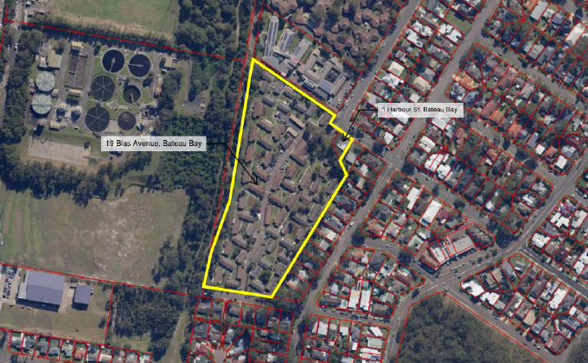

Above: Aerial view of site outlined in yellow

1. **THE PROPOSAL AND BACKGROUND** 
   1. **The Proposed Modification**

The proposal seeks modification under Section 4.55(2) of the consent recently granted for a seniors housing development including the construction of a seniors housing development in stages comprising demolition works, construction of a residential care facility (RACF) with independent living units (ILU’s) with associated on-site support services and communal facilities, car parking, landscaping, and other ancillary works.

The modifications sought only relate to buildings 2, 5 and 6 which are part of the Stage 1 works under the original consent. Block 2 and 5 are 3 storey buildings, and Block 6 is a 2 storey building. It is sought to modify Block 2 to comprise 27 units (previously 25 units) and to modify Block 5 to comprise 27 units (previously 25 units) and to modify Block 6 to comprise 22 units (previously 24 units). Blocks 2 and 5 have a partial level of car parking at semi-basement level. Block 6 has no car parking located within the building footprint but utilises parking in Block 5.

The modifications being sought include:

* Reconfiguration of floor plates and internal layout of buildings 2, 5 and 6 resulting in:

- an increase in the number of units from 74 (approved) to 76 (2 additional dwellings),

- changes to the internal floor plates to gain efficiencies and improvements in amenity,

- study nooks removed from units and storage provided,

- lifts and forestairs reconfigured, and

- allowance for building services to be incorporated into the design.

* Minor alterations to the external facades of buildings 2, 5 and 6 to accommodate a more functional building and in response to the internal layout changes. This includes

the proposed removal of balconies, and changes to windows and doors to reflect internal layout changes, a reduction to the extent of glazing, the external walls of units in Block 2 and 5 moved further from the boundary due to more efficient core configuration.

* Minor alterations to, and reconfiguration of, parking layout for buildings 2 and 5 including adjustment to the column layout to be more efficient with provision of 3 additional parking spaces, 2 additional motorcycle spaces and 14 additional bicycle spaces.
* Alterations to the roof form to buildings 2, 5 and 6 to support an adjustment to mechanical plant. Roof shape refined and overhand reduced. Minor alterations to the roof form of Buildings 2, 5 and 6 to accommodate mechanical plant including 200mm increase to lift overruns and increase concrete wall around plant decks by 200mm to 1400mm to match lift overrun height. Also including changes to roof over southern units of Block 2 from pebbles over a slab to a metal deck roof over slab (for weather-proofing).
* Privacy fencing/landscaping added to western ground floor apartments. Planters to eastern terrace to increase privacy along eastern boundary.

The changes rationalise the unit layouts and access and parking areas for more efficiencies and improved functionality. Under the modification various parts of the approved building have been pull away from the eastern boundary (adjoining the R2 zone land) and the removed floor area has been relocated to the western side of the building.

These reductions in built form along the eastern boundary results in a greater setback for these affected parts. The building heights either maintain the originally approved RL or less. There is a minor decrease in GFA (by 69m²) which does not result in any discernible change in FSR. There is no change to the approved staging. The modification works relate to Stage 1.

The total number of independent living units will increase by 2 units from a total of 180 to 182 dwellings (or for Stage 1 from 74 units to 76 units). There are no additional ILU’s along the eastern interface and no reduction in landscaping within this setback. Proposed changes to parking include 3 extra spaces (to cater for the increase in units) which are positioned as 1 extra space for each building. Additionally, changes to the car parks included relocated and resized storage areas, relocation of waste room (block 2), new waste room (block 6), more practical location for electrical and comms rooms, provision of space for services. Additional landscaping is proposed around block 6.

The modification includes changes to the dwelling mix which will result in 4 fewer 1-bedroom units, 4 fewer 3-bedroom units and 10 additional 2-bedroom units. This is an increase in the total number of bedrooms between the 3 buildings from 146 to 150.

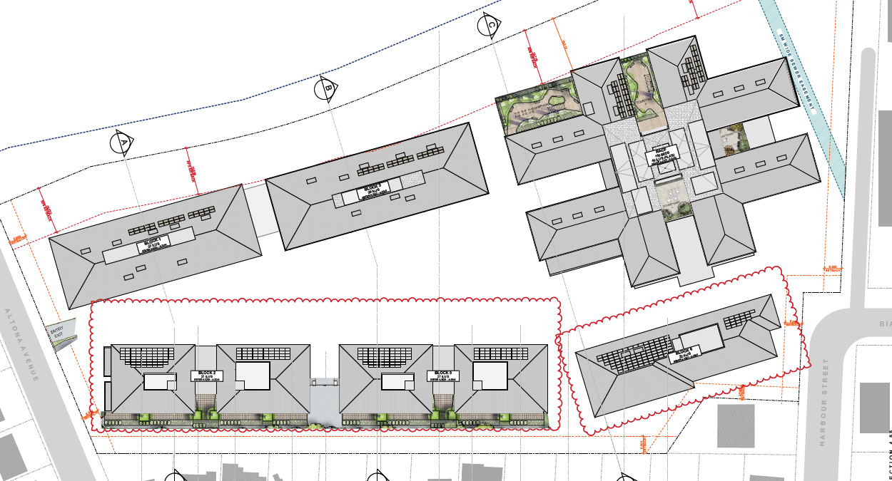

Above: Buildings 2, 5 and 6 clouded in red above to be modified.

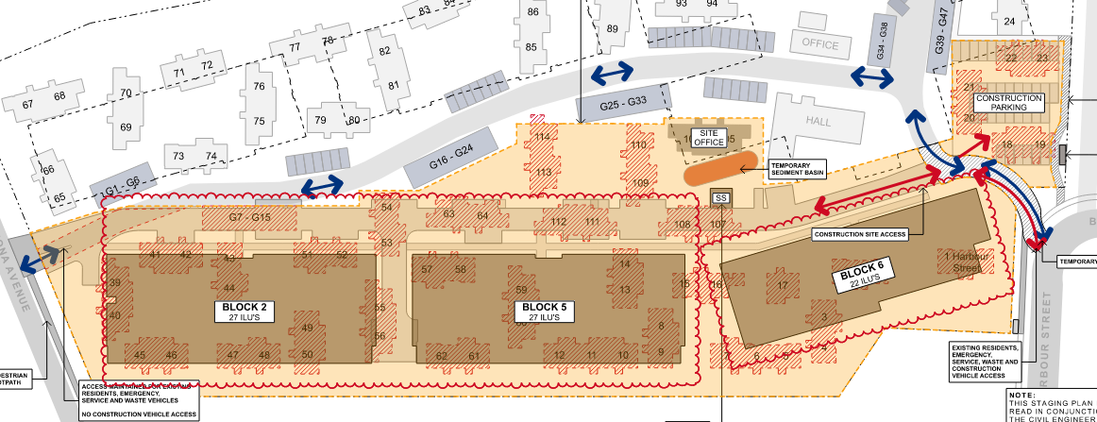

Above: Stage 1 of the approved development

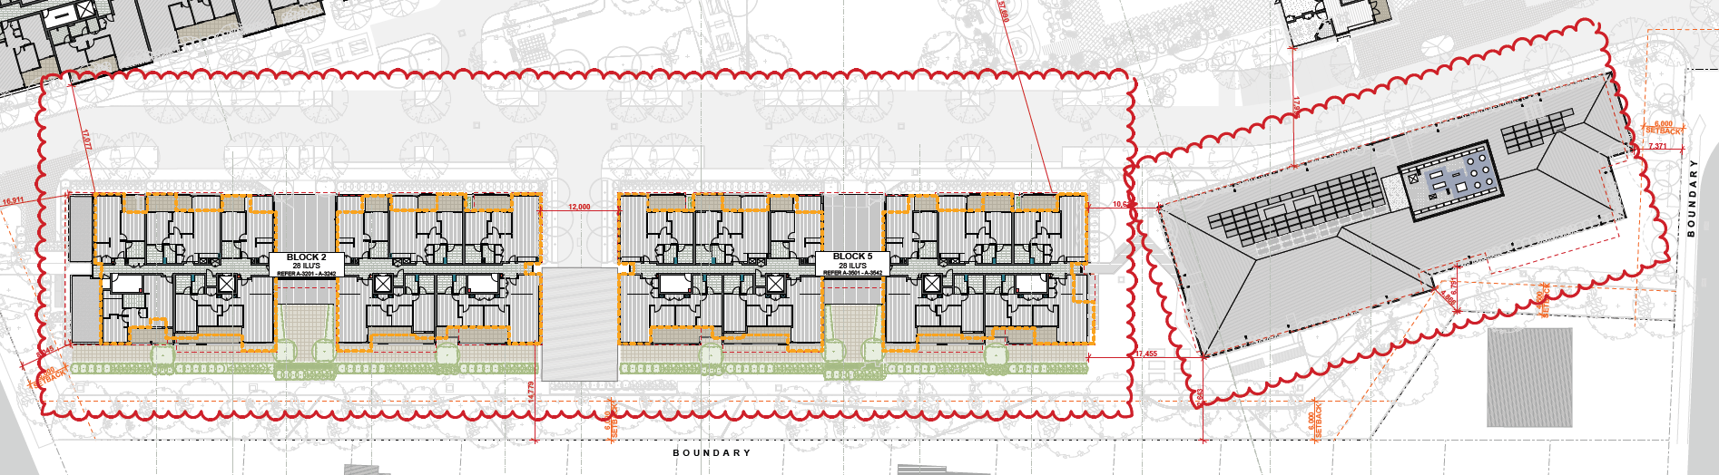

Above: Outline of DA approved building in yellow

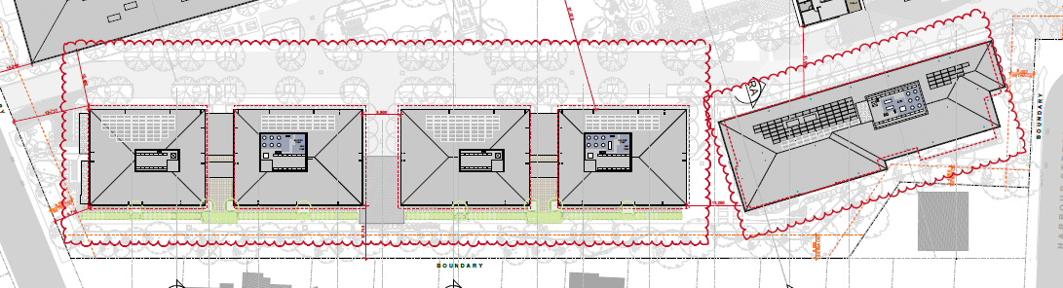

Above: Footprint of approved DA in red.

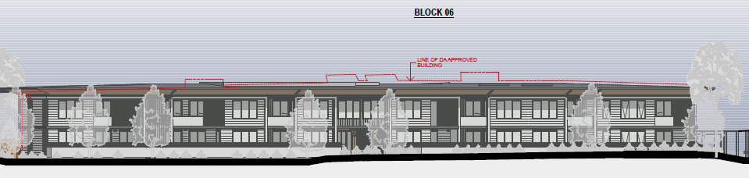

Above: View of Block 6 from Ocean view Drive

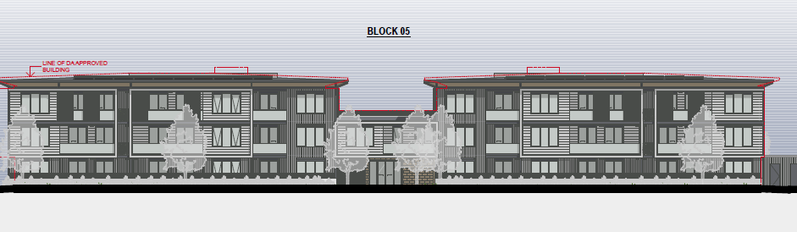

Above: View of Block 5 from Ocean view Drive

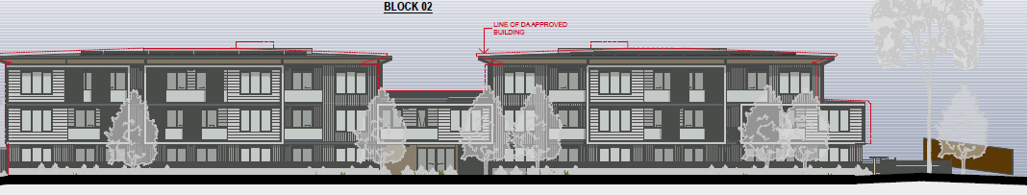

Above: View of Block 2 from Ocean view Drive

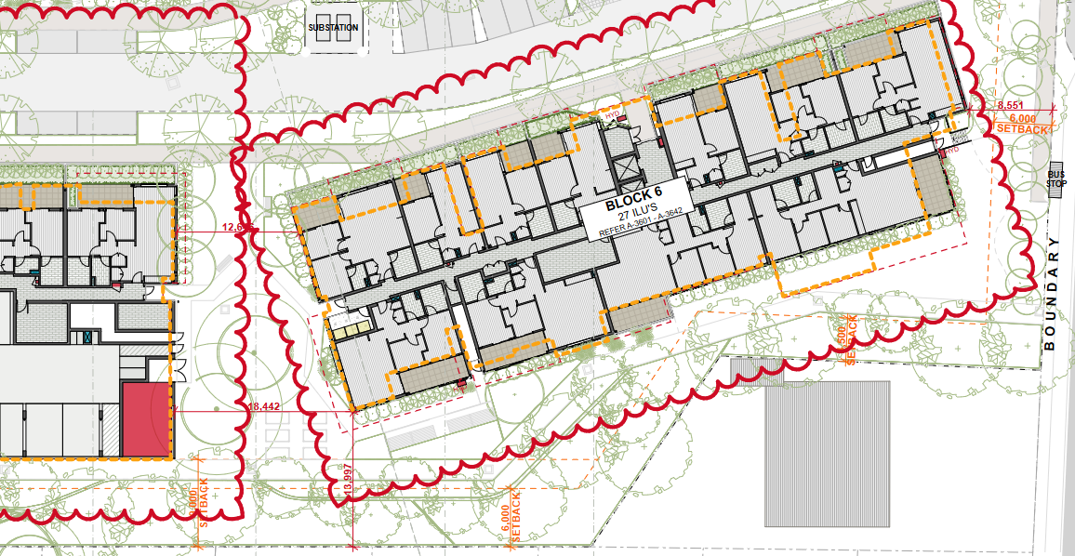

Above: Modified setbacks for Building 6

*Proposed Changes to Conditions*

The application includes modification to condition 1.1 which relates to the approved plans to be updated to reference the latest plans under the modification. Modification to condition 1.4 in relation to the agency advice that the earlier GTA’s are satisfactory and are to remain unchanged. Modification to condition 2,3 to require some minor plan amendments prior to issue of a Construction Certificate.

**Table 1: Proposed Changes to Conditions**

|  |  |  |  |
| --- | --- | --- | --- |
| **Condition No** | **Condition requirements** | **Change Proposed** | **Reason for Change** |
| 1.1 | Approved plans and documents | Modify architectural plans and associated documents | Modify to update plans to reflect proposed modification |
| 1.4 | GTA’s | Include reference to correspondence from agencies confirming GTA’s unchanged | Reference to Agency advice. |
| 2.3 | Amendments requiring a change to allow for new sub-point c). | Prior to issue of a CC for any building within Stage 1, Unit types 3B03 and 3B04 are to be re-designed to provide adequate storage by re-orientating the bathrooms and reconfiguring the study nook. | To improve compliance, functionality and amenity to larger units by allowing for increased areas for storage. |
| 2.3 | Amendments requiring a change to allow for new sub-point d). | Prior to issue of a CC for any building within Stage 2, the plans are to show the location for a common accessible toilet for visitors. | To compensate for the loss of the approved common accessible toilet within Stage 1 under the latest plans. |
| 2.3 | Amendments requiring a change to allow for new sub-point e). | Prior to issue of a CC for any building within Stage 1, the plans are to show a section of the proposed planting on terraces. | To demonstrate that the planting can be practically and successfully achieved in this form. |

*Development Data*

Development data is provided in the table below to allow for comparisons between the approved and proposed modified development.

**Table 1: Key Development Data**

|  |  |  |  |
| --- | --- | --- | --- |
| **Control** |  | **Approved DA** | **Modification** |
| Site area |  | 38, 240m² (total)  Comprising:  -37,000m² 19 Bias Ave (R1 zone)  -623m² 1 Harbour Street (R2 zone | No change |
| GFA |  | 33, 265m² (total)  - 12, 484m² RACF*  - 20,781m² ILU** | 33, 193m² (total)  No change  Reduction (- 69m²) |
| FSR |  | 0.87:1 | 0.87:1 |
| No of apartments  No of RACF Beds |  | 180 units  (74 units in stage 1)  160 Beds | 182 units (1% increase)  (76 units in Stage1)  No change to beds |
| Max Height |  | 16.4m (RACF)  12.33m (Block 1)  11.85m (Block 2)  15.19m (Block 3)  11.02m (Block 5)  9.75m (Block 6) (floor to ceiling height is 7.87m) | No change  No change  Complies  No change  Complies  Complies |
| Landscaped area |  | 17,260m² (soft landscaping) 45% | 17,452m²  (1% increase) |
| Deep Soil |  | 10,984m² | 11,112m² (1% increase) |
| Car Parking spaces |  | 263 spaces  -  -  133 spaces – all ILU’s  (71 spaces Stage 1 ILU’s)  -  22 spaces ILU/ALA*** resident  70 spaces - RACF staff  20 spaces RACF resident  18 RACF visitor  -  Minibus – 1 space  Ambulance – 5 spaces  Caravan – 2 spaces  -  Motorcycle spaces  6 (total – all stages)  (Stage 1 had 2 spaces)  -  No bike spaces (stage 1)  11 bike spaces (total but in later stages) | 266 spaces (1% increase) (1 extra space in Blocks 2 & 5 & 6)  136 spaces- all ILU’s  (74 spaces Stage 1 ILU’s)  -  No change  -  -  No change  No change  -  No change  -  No change  No change  No change  -  +2 motorcycle spaces (Stage 1)  -  -  +14 bicycle spaces (stage 1) |
| Boundary Setbacks  (Min)  Northern to adjoining RACF  Eastern (to Lakin Street lots)  Western (to Saltwater creek |  | Bias Ave (Block 6):8.17m  -  Altona Ave (Block 2): 6.6m  Altona Ave (Block 1): 8m  Northern Side (RACF): 9.85m  Eastern Side (Blocks 2 & 5): 9m  Eastern Side (Block 6): 6.2m(closest)  -  Western Side (Block 1 & 3):16m  Western Side RACF:19.8m | 8.551m (0.381m increase)  -  6m (0.6 decrease)  -  No change  No change  -  9.018m  -  7.45m  -  -  No change  No change  No changes to Blocks 1, 3 or RACF |
| Loading |  | Waste collection separate exit (ILU’s) and more screening  RACF loading dock | No change to RACF. Waste management arrangements for ILU’s satisfactory |
| Communal Open Space |  | 26% (9942m²) | No change |
| Affordable units |  | 23 | 23 |
| On site support services |  | 414m² | 414m² |

*RACF – Residential Aged Care Facility

**ILU – Independent Living Units

***ALA- Assisted Living Apartments

* 1. **Background**

The proposed modification application was lodged on 24 January 2024. A chronology of the modification application since lodgement is outlined below in **Table 3** including the Panel’s involvement (briefings, deferrals etc) with the application:

**Table 3: Chronology of the Modification Application**

|  |  |
| --- | --- |
| **Date** | **Event** |
| 24 January 2024 | Modification application lodged |
| 2 February 2024 | Exhibition of the application (to 23 Feb 2024) |
| 24 January 2024 | Modification referred to external agencies |
| 13 June 2024 | Request for Information from Council to applicant |
| 2 July 2024 | Panel briefing |
| 12 July 2024 | Further RFI following Panel briefing. |
| 2 August 2024 | Amended plans lodged |
| 25 September 2024 | Panel electronic determination |

* 1. **Site History**

Development Consent No DA/882/2021/A (PPSHCC-86) was granted by the Hunter and Central Coast Regional Planning Panel on 30 November 2022. Extracts from the Panel minutes of that determination meeting are included below.

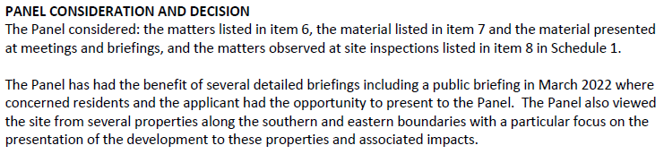

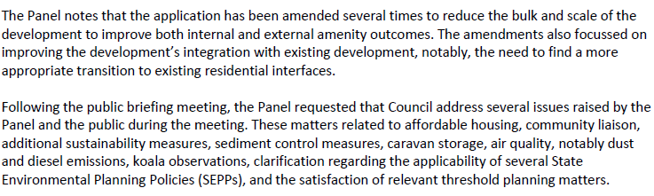



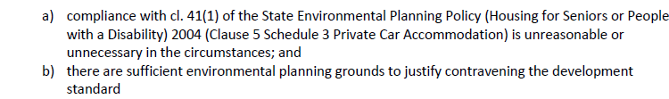

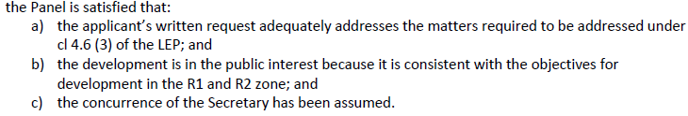

The reasons for the Panel’s decision are outlined later in the report. In relation to community concerns the following was noted:

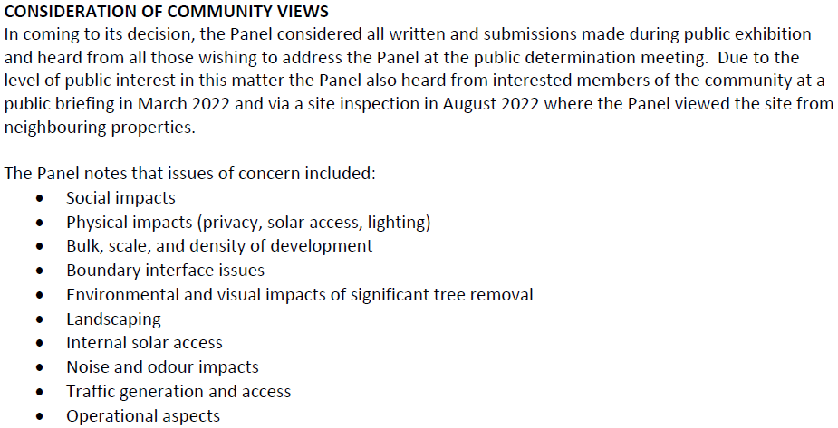

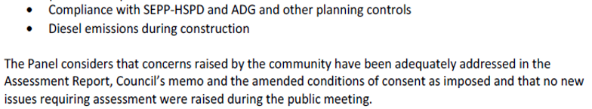

A Panel Briefing was held on 9 July 2024 with the Regional Planning Panel and the following key issues were discussed.

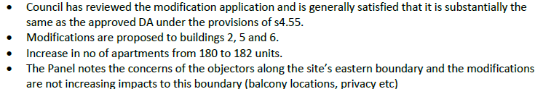

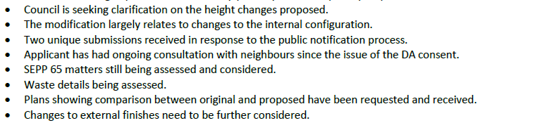

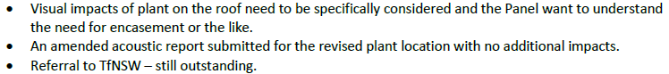

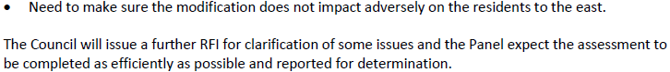

Revised plans and supporting information was provided by the applicant and has been assessed as satisfactory. The matters raised above have been discussed below throughout the report.

1. **STATUTORY CONSIDERATIONS**

When determining a modification application, the consent authority must take into consideration the matters outlined in 4.55(2) of the EP&A Act in relation to modification of consents provisions, Section 4.15(1) of the EP&A Act in relation to matters for consideration for applications and Part 5 of the 2021 EP&A Regulationin relation to information requirements and notification. These matters are considered below.

* 1. **Section 4.55** **of the EP&A Act**

**Modification of Consents - Section 4.55(2)**

In accordance with Section 4.55 (2) of the EP&A Act, a consent authority may modify a consent provided:

1. *it is* *satisfied that the development to which the consent as modified relates is substantially the same development as the development for which consent was originally granted and before that consent as originally granted was modified (if at all), and*
2. *it has consulted with the relevant Minister, public authority or approval body (within the meaning of Division 4.8) in respect of a condition imposed as a requirement of a concurrence to the consent or in accordance with the general terms of an approval proposed to be granted by the approval body and that Minister, authority or body has not, within 21 days after being consulted, objected to the modification of that consent, and*
3. *it has notified the application in accordance with—*
4. *the regulations, if the regulations so require, or*

*(ii)  a development control plan, if the consent authority is a council that has made a development control plan that requires the notification or advertising of applications for modification of a development consent, and*

1. *it has considered any submissions made concerning the proposed modification within the period prescribed by the regulations or provided by the development control plan, as the case may be.*

Substantially the same development (s.4.55(2)(a))

A consent authority must be satisfied that the development to which the consent as modified relates is substantially the same development as the development for which consent was originally granted. This is a necessary jurisdictional position that must be established in the assessment of the proposal. The proposed modifications to the development as *originally* approved, inclusive of the latest plans are as shown earlier in Table 1.

It is considered that the modified development is substantially the same development to that originally approved and that the impacts of the change are minimal. There are no significant or unreasonable changes to the building height or approved boundary setbacks for Buildings 2, 5 and 6 and the development continues to comply with relevant planning controls, even improving compliance in a number of instances.

The proposed changes are considered unlikely to adversely impact on the amenity of nearby residents and the modified development does not represent a radical change to the form, bulk, and scale of the originally approved development on the site and there is little to no discernible change to the scale and external appearance of the proposal when viewed from surrounding streets or neighbouring properties.

The proposal does not represent a transformation of the qualitative and quantitative elements of the originally approved development and the development is considered to be substantially the same development for which consent was originally granted. The modified plans have provided two additional housing options and have improved the quality of the housing outcome under the proposal in addition to improving the amenity for the future occupants.

The proposed changes are minor and do not substantially alter the originally approved development on the land and the changes to the built form and not significant.

Consultation (s.4.55(2)(b)

The original and modified applications were required to be referred to the following external authorities for comment.

* NSW Rural Fire Service
* NSW Department of Planning and Environment- Water
* Transport for NSW

No objections were raised by external authorities and the earlier issues GTA’s remain unchanged as discussed later in the report.

Notification (s.4.55.(2)(c)(d))

The modification application was notified between 2 Feb – 23 Feb 2024 in accordance with Wyong DCP Chapter 1.2- Notification of Development Proposals. There were 2 submissions received. The issues raised in these submissions are considered in Section 4 of this report.

Section 4.55(3)

Section 4.55 (3) reads:

*In determining an application for modification of a consent under this section, the consent authority must take into consideration such of the matters referred to in section 4.15(1) as are of relevance to the development the subject of the application. The consent authority must also take into consideration the reasons given by the consent authority for the grant of the consent that is sought to be modified.*

Section 4.55(3) requires the consent authority to consider matters referred to in Section 4.15(1) as are relevant to the application for modification of the development consent.

* *Matters for Consideration (Section 4.15(1))*

When determining a development application, the consent authority must take into consideration the matters outlined in Section 4.15(1) of the *Environmental Planning and Assessment Act 1979* (‘EP&A Act’). These matters as are of relevance to the development application are discussed in detail further below (under Section 3.2). The modification has been assessed against the matters for consideration under Section 4.15 of the Act and found to be satisfactory with regard to impacts upon the residential amenity of future occupants and compliance with the relevant ADG planning controls. These matters are further considered below and are discussed later in the report.

* *Reasons for the Decision*

Additionally, under Section 4.55(3) consideration must be given to the reasons for the granting of the original approval. In this regard the HUNTER AND CENTRAL COAST REGIONAL Planning Panel granted consent to the original development in a notice of determination dated 30 November 2022 The reasons outlined in the Statement of reasons for this decision included the following:

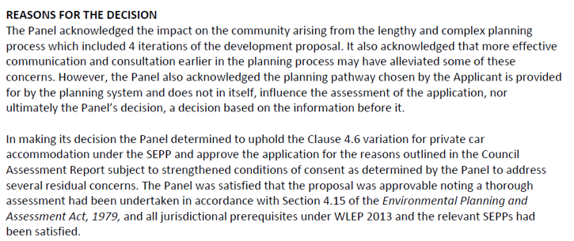

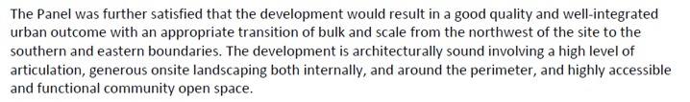

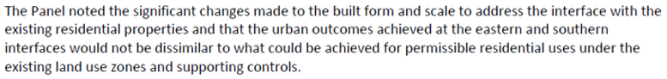

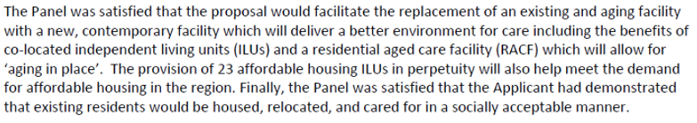

The modified proposal is considered satisfactory with regard to the above original reasons for the granting of consent.

The proposed modification is considered consistent with these reasons for the decision on this consent in that the proposed development is generally consistent with the planning controls and expectations for the site given the zoning and other planning controls for the site.

* 1. **Section 4.15(1) of the EP&A Act**

Section 4.15(1) of the EP&A Act contains matters which the consent authority must take into consideration in determining a development application and modification applications pursuant to Section 4.55(3), which are of relevance to the application.

These matters include the following, which are considered in detail below:

1. *the provisions of—*
2. *any environmental planning instrument, and*
3. *any proposed instrument that is or has been the subject of public consultation under this Act and that has been notified to the consent authority (unless the Planning Secretary has notified the consent authority that the making of the proposed instrument has been deferred indefinitely or has not been approved), and*
4. *any development control plan, and*

*(iiia) any planning agreement that has been entered into under section 7.4, or any draft planning agreement that a developer has offered to enter into under section 7.4, and*

1. *the regulations (to the extent that they prescribe matters for the purposes of this paragraph),*

*that apply to the land to which the development application relates,*

1. *the likely impacts of that development, including environmental impacts on both the natural and built environments, and social and economic impacts in the locality,*
2. *the suitability of the site for the development,*
3. *any submissions made in accordance with this Act or the regulations,*
4. *the public interest.*

These are discussed in further detailed under the assessment below.

* + 1. **Section 4.15(1)(a) - Provisions of Environmental Planning Instruments, Proposed Instruments, DCPs, Planning Agreements and the Regulations**

The relevant provisions under s4.15(1)(a) are considered below.

**(a) Section 4.15(1)(a)(i) - Provisions of Environmental Planning Instruments**

The following Environmental Planning Instruments are relevant to this application:

* *State Environmental Planning Policy (SEPP) (Resilience and Hazards) 2021*
* *SEPP (Transport and Infrastructure) 2021*
* *SEPP (Planning Systems) 2021*
* *SEPP No.65 - Design Quality of Residential Apartment Development*
* *SEPP (Building Sustainability Index: BASIX)*
* *SEPP (Biodiversity and Conservation) 2021*
* *SEPP (Housing for Seniors or People with a Disability) 2004*
* *SEPP (Housing) 2021*
* *SEPP (Industry and Employment) 2021*
* *Central Coast Local Environmental Plan 2022*
* *Wyong Local Environmental Plan 2013*

A summary of the key matters for consideration arising from these State Environmental Planning Policies are outlined in **Table 4** and further discussion only on the key instruments considered in more detail below.

**Table 4: Summary of Applicable State Environmental Planning Policies**

|  |  |  |
| --- | --- | --- |
| **EPI** | **Matters for Consideration** | **Comply (Y/N)** |
| State Environmental Planning Policy (Planning Systems) 2021 | Section 2.19 declares the original proposal as regionally significant development pursuant to Clause 2 (General Development over $30 million) of Schedule 6 of the SEPP (Planning Systems) 2021. The CIV provided for the approved exceeded this value. The modified development is of a type described under Part 15, Division 1, Section 275(2) of the EPA Regulation 2021. | Y |
| SEPP 65- Design Quality of Residential Apartment Development | Clause 30(2) - Design Quality Principles - The design quality principles and the Apartment Design Guide (ADG) requirements apply to the approved and modified proposal. The proposal is satisfactory and consistent with the provisions of SEPP. | Y |
| SEPP (Resilience and Hazards) | Chapter 3 (Remediation of Land) - Potential contamination and remediation has been considered in the assessment of the proposal. The site has had a historical use for aged care residential purposes. Preliminary geotechnical investigations of the site did not identify any materials suggesting the site is likely to be contaminated. The modified development does not propose to alter the building footprint or excavate any additional areas beyond the original approval.  Chapter 2 (Coastal Management) - The site is not located within either the Coastal Use Area or the Coastal Environment Area. | Y |
| SEPP (Transport and Infrastructure) 2021 | Clause 2.122 (& Schedule 3) - Traffic-generating development. The nearest classified road is The Entrance Road which is 350m to the west of the site, however the proposal includes parking provision which exceeds the stated capacity under Column 2 of Schedule 3 of the SEPP. The DA was referred to Transport for NSW for comment.  The modified proposal has been referred to TFNSW who advised: *TfNSW has reviewed the information provided and raises no objection to or requirements for the proposed development as it is considered there will be no significant impact on the nearby classified (State) road network.* | Y |
| SEPP (Housing for Seniors and People with a Disability) 2004 | The application was approved under the SEPP (Housing for Seniors and People with a Disability) 2004 (SEPP HSPD). The modified development remains satisfactory with regard to approved compliance with the SEPP. | Y |
| BASIX SEPP | Basix Certificate 1188112M (dated 30 Sept 2022) was provided for the original development. A revised Basix Certificate (1188112M_07) has been provided for the modification along with revised a Basix report and NatHERs assessment. | Y |
| SEPP (Biodiversity & Conservation) 2021 | The modified development does not propose to remove or alter any vegetation beyond that approved under the original DA, therefore having no adverse impact on koalas or koala habitat. | Y |
| SEPP (Housing) 2021 | This SEPP commenced on 26 Nov 2021.The DA was lodged prior to the commencement of this SEPP and the savings provisions apply (under Schedule 7A (Savings and transitional provisions). | Y |
| SEPP (Industry and Employment) 2021 | The modification does not propose to alter any of the approved signage across the site. | Y |
| CCLEP 2022 | CCLEP 2022 commenced 1 August 2022. The savings provisions apply to this DA which was lodged prior to the commencement of CCLEP 2022. Under CCLEP 2022, the site retains its R1 and R2 Residential zonings and Senior’s housing remains permissible with consent. | Y |
| WLEP 2013 | Clause 2.3 - Zone objectives and Land Use Table  Clause 4.3 - Height  Clause 4.4 - FSR  Clause 5.10 - Heritage conservation  Clause 5.21 - Flood Planning  Clause 7.1 - Acid Sulphate Soils  Clause 7.3 - Floodplain Risk Management  Clause 7.9 - Essential Services | Y |
| WDCP 2013 | -Chapter 1.2 - Notification of Development Proposals.  -Chapter 2.4 - Multiple Dwelling Residential Development  -Chapter 2.1 - Parking and Access  -Chapter 3.1 - Site Waste Management  -Chapter 3.3 - Floodplain Management | Under assessment |
| CCDCP 2022 | The application predates the operation of CCDCP 2022 and therefore Wyong DCP 2013 applies. There is no significant change in relevant DCP controls for parking or other matters under CCDCP 2022. | Y |

State Environmental Planning Policy (SEPP) No. 65 – Design Quality of Residential Apartment Building and the Apartment Design Guideline (ADG)

State Environmental Planning Policy 65 (Design Quality of Residential Apartment Development) (SEPP 65) applies to the development and requires the design quality of the development to be taken into consideration and evaluated against the design quality principles. The proposed modification has also been assessed against the Apartment Design Guide (ADG)

The modification results in little or no change to the majority of the planning controls that apply. The following aspects have been modified and are discussed below.

*Building Height*

The building height under the modified proposal maintains compliance with the applicable planning controls. Most roof elements in Block 2 have been reduced in height when compared to the approved plans. The floor levels of Block 2 are the same as the original approval. The plant deck level has been reduced by 0.2m and the height of the lift overrun has been reduced by 0.6m. The height of the gutter has been reduced by 0.08m. The top of the wall surrounding the plant has been increased slightly by 0.1m however, this will not be in ready view.

The floor levels of Block 5 are the same as the original approval. Most of the Block 5 roof elements have been reduced in height when compared to the approved plans. The plant deck level has been reduced by 0.2m and the height of the lift overrun has been reduced by 0.6m and the height of the gutter has been reduced by 0.08m. The top of the wall surrounding the plant has been increased slightly by 0.1m but again, this will not be within ready view.

Block 6 has an overall reduced height compared to the original approval. The step in the ground floor level of Block 6 has been removed. The ground floor levels of the original approval had an RL of 15m on the high side and an RL of 14.25m on the low side. The proposed modification has a ground floor level of 14.55, which is 0.45m below the original higher ground floor. The first floor of Block 6 has a floor level 0.45m below the approved DA. The plant deck level has been reduced by 0.55m. The height of the lift overrun has been reduced by 1.2m, the height of the gutter has been reduced by 0.26m and the top of the wall surrounding the plant has been decreased by 0.15m.

*Floor Space Ratio (FSR)*

The FSR continues to comply under the modified proposal. There is a reduction in GFA under the modified development. This appears to have been achieved through rationalising the floor plans and making them more efficient.

*Building separation and setbacks*

There is no change under the modified design with regard to compliance with the separation requirements. Balconies on the south elevations have been removed and the building line along the eastern boundary setback has increased by 1m. Despite the changes to the setbacks, the separation between buildings is at least 12m within the site. Separation to the side boundary of the adjoining residences much more than 6m in most areas.

Building separation is adequate in the proposed modification. Bedrooms are located away from noise sources. A lot of plant has been moved from rooms on the ground floor up to the roof in the proposed modification. An acoustic wall is proposed around the plant platform to lower noise by a minimum of 10dB. The acoustic report states that the level of noise from the plant is the same as that which was assessed in the approved DA. There is therefore no change under the modification.

The modified proposal continues to comply with the setback requirements. The minimum proposed setback to the boundary at the corner of Bias Avenue and Harbour Street exceeds 8.5m. The minimum proposed setback to the boundary with Altona Street is 8m. Block 6 setbacks to the side or rear boundary are a minimum of 7.5m. The setbacks of Blocks 2 and 5 to the side or rear boundary are well in excess of 6m.

*Privacy*

The modification includes windows being rationalised and the overall extent of glazing reduced. Some balconies (facing east) have been removed and privacy fencing and landscaping has been added to the western ground floor apartments. Planters added to eastern terraces to provide more buffer planting to increase privacy along the eastern boundary. Additional landscaping has been added to the eastern boundary setback of Block 6 and the building setback to the eastern boundary have been increased. Under the modified development the windows facing each other in Blocks 2 and 5 have a sill height of 1900mm which maintains visual privacy.

*Private Open Space areas*

The modified proposal complies with the minimum private open space areas. There is one unit type 3-bedroom Type 04 that has a balcony that is 2.35m wide which is just under the minimum width, but the balcony area is generous and allows enough room for furniture.

*Common circulation spaces*

The ADG requires:

*The maximum number of apartments off a circulation core on a single level is 8.*

*Where a development is unable to achieve the design criteria, a high level of amenity for common lobbies, corridors and apartments should be demonstrated. Where this design criteria is not achieved, no more than 12 apartments should be provided off a circulation core on a single level.*

The maximum number of units off a circulation core on a single level under the modified proposal varies from 5-11 units, which is less than the approved DA that had some levels with 12 units off a single circulation core.

The corridors have openings providing access to natural light and ventilation, and indentations around entry doorways. Corridors are linear and split into two parts, servicing a maximum of 6 units off each part. The modified proposal is considered to improve compliance.

*Storage*

The ADG requires:

*In addition to storage in kitchens, bathrooms and bedrooms, the following storage is provided:*

*Studio – 4m³*

*1 bedroom – 6m³*

*2 bedroom – 8m³*

*3+ bedroom – 10m³*

*At least 50% of required storage to be located within the apartment*

There are a total of 9 out of 76 units that do not have the minimum required storage located within the unit. It appears from the plans that no units achieved the minimum requirements of storage within the units. However, the proposed modification provides significantly more storage within units than the originally approved DA and on this basis is considered satisfactory.

The storage in two of the 2-bedroom units 2B02 and 2B05 while being inadequate, can be made up with external storage in the basement. The storage in two of the 3-bedroom unit types in the proposed modification is significantly less than the required minimum. This is unit types 3B03 and 3B04, which only have 1.1m³ and 1.8m³ when it should have 5m³. The deficiency in storage is not able to be made up in the external storage.

These units can be redesigned to provide adequate storage by re-orientating the bathrooms and reconfiguring the study nook. This will be addressed under the recommended modified conditions requiring these units be redesigned to provide more storage area (refer to modified condition 2.3c)).

The ADG also requires basement/external storage to be clearly allocated to specific apartments and the modified proposal demonstrates compliance. Blocks 2 and 5 have 27 units each and 27 storage cages on the ground floor of various sizes that comply with the minimum requirements for the number of bedrooms in the unit.

Block 6 has 11 units on each level and 11 storage cages on each level of various sizes that comply with the minimum requirements for the number of bedrooms in the unit.

*Solar access*

Solar access complies under the modified development proposal as follows:



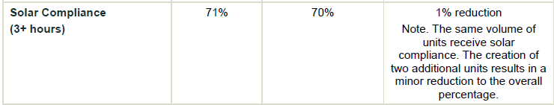

Contrary to the applicants table there are 22 out of 30 units (73%) that receive 3 hours solar access as required under the control. There are 4 out of 30 units (13%) which do not receive any direct sunlight and this complies with the maximum of 15% of total units permitted under the ADG.

*Cross Ventilation*

Cross Ventilation complies under the modified development proposal as follows:



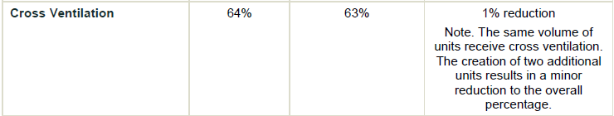

There are 48 out of 76 units (63%) which are dual aspect or have an operable skylight and so achieve cross ventilation. Note that this is more than the approved DA where 57% of the units achieved cross ventilation in Stage 1.

*Landscaping*

The landscaping and deep soil mix is proposed to be modified as follows:

**



Updated landscape plans have been provided for the proposed modification which increase the planting to planter boxes and to various setbacks including the eastern boundary to the R2 zoned land. The buffer planting is proposed on the terraces of level 1 of Blocks 2 and 5 along the eastern boundary facing the existing residential. However, there are no details in the landscape plans showing how this is to be achieved. This will be addressed under the recommended modified conditions (refer to modified condition 2.3e)).

*Common accessible toilet*

The accessible toilets on the ground floor in Block 2 and Block 5 included under the original approved development have been removed in the proposed modification. There was no accessible toilet in the approved Block 6 or in the proposed modification. There is one accessible toilet in the approved RACF building. There are no public toilets proposed in the park near the outdoor facilities. There is therefore no common accessible toilet facility available for visitors or contracting staff. This will be addressed for Stage 2 of the development under the recommended modified conditions (refer to modified condition 2.3d)).

*Parking*

The parking under the modified development has been increased by 3 spaces from 263 spaces to 266 spaces. Under the original consent it is noted that for a social housing provider, 36 spaces are required to be provided for the 180 self-contained dwellings under the SEPP HSPD. The modified proposal includes 2 additional independent living units and the SEPP requires parking provision on the basis of 1 space per 5 dwellings which would only marginally increase the parking demand by 1 space.

The approved DA for Stage 1 included 74 units so a minimum of 15 spaces were required according to SEPP HSPD. The approved DA had 71 spaces which exceeded the minimum requirement under the SEPP. The modified development includes 76 units so a minimum of 16 car spaces are required according to the SEPP. The modification includes proposed 74 spaces which exceeds the minimum required under SEPP HSPD. The modification has 3 more spaces than was provided in the approved DA for Stage 1 and this arrangement is considered satisfactory.

Additionally, the parking space design complies with the SEPP in that 20 spaces (6.5%) of the total spaces are designed to enable the width of the space to be increased to 3.8m and all garage doors are power operated. This exceeds the SEPP requirement for 5% of total spaces. The parking continues to be satisfactory with regard to the SEPP HSPD.

The proposed modification also includes 4 motorbike/ scooter spaces whereas 2 motorbike/ scooter spaces were approved in Stage 1. The proposed modification has 14 bicycle parking spaces within the undercover car parking area of Blocks 2 and 5. The approved DA had no bicycle parking spaces in Stage 1.

*Unit Mix and size*

The unit mix for the Independent Living Units in Stage 1 is proposed to be modified as follows:

Units Approved Modified Change

1 Bedroom 25 21 16% decrease

2 Bedroom 26 36 38% increase

3 Bedroom 23 19 175 decrease

The modified apartment mix still comprises a range of 1, 2 and 3-bedroom units. The distribution is now 47% as 2-bedroom units, whereas the approved DA generally had a third of units as 1, 2 or 3-bedrooms. This is probably more reflective of the majority of user groups.

The modified proposal complies with the minimum apartment sizes and with the minimum room sizes There are some small rooms in two of the 1-bedroom units but these have been identified as a ‘study’ and are not a bedroom. There is one unit type 2-bedroom Type 05 has a dining area that measures 3.7m however the living area has a width of 4m.

*External Facades, entries and roof treatment*

The ADG requires that *building facades provide visual interest along the street while respecting the character of the local area.* The modified proposal continues to comply having slight modifications in the façades which have been made in response to changes in the floor plans. Other changes include window openings that have been consolidated, lift over runs have been reduced, planter areas added to balconies, and changes to cladding materials in some locations. The architectural style continues to respect the character of the local area.

Building functions are expressed in the facades, private open space areas are legible and the ground floor entry areas are made more distinct by centralising them and changing materials around the entry.

The roof design continues to comply under the modified design. There have been minor modifications made to the roof design with the inclusion of a sunken plant deck within the roof. Lift overruns have been reduced to the same height as the plant equipment and are concealed by an acoustic wall. Images provided in August 2024 demonstrate that the plant areas will not be visible or hardly visible as the upturn in the eaves overhang conceals them.

The proposed modification has been assessed against the 9 Design Quality Principles (SEPP 65) as follows:

|  |  |  |
| --- | --- | --- |
| **#** | **Principle** | **Comment** |
| 1 | Context and neighbourhood character | No change in proposed modification. |
| 2 | Built form and scale | Minimal change in proposed modification. |
| 3 | Density | Minimal change in proposed modification. There has been a slight increase in total unit numbers, but this has been achieved with a more efficient floor plan and with a minor reduction in floor area. |
| 4 | Sustainability | Minimal change in proposed modification. |
| 5 | Landscape | Minimal change in proposed modification. |
| 6 | Amenity | Minimal change in proposed modification. There is opportunity however to provide more adequate storage in two of the 3-bedroom unit types as discussed earlier in the report and this has been addressed under the recommended conditions. |
| 7 | Safety | Minimal change in proposed modification. |
| 8 | Housing Diversity and Social Interaction | Minimal change in proposed modification. |
| 9 | Aesthetics | There have been some minor changes to the aesthetics of the facades due to changes in floor plans. Some window openings have been reduced in size or consolidated into a single window set. Some cladding changes are proposed but these make sense in that higher quality finishes are used to define entry areas to buildings, for example the use of sandstone cladding and timber battens. The amount of sandstone wall cladding has been reduced but this is generally in areas where the sandstone wall cladding would be obstructed by landscaping or fencing, or where it is located at the sides of buildings. The modifications are satisfactory with regard to aesthetics. |

The modifications, as proposed largely comply with the ADG and SEPP 65 and will only result in minor and acceptable non-compliances with a number of ADG planning controls. The latest revised plans for the modified proposal are supported.

*Wyong Local Environmental Plan 2013*

*Permissibility and zone objectives*

The site is located within the R1 - General Residential zone with a smaller lot included that is zoned R2 Low Density Residential zone pursuant to Clause 2.3 of the Central Coast LEP 2022 (CCLEP 2022). However, the DA was assessed under Wyong LEP 2013 (WLEP) (being lodged prior to the adoption of the CCLEP on 1 Aug 2022 and being subject to the saving provisions under Clause 1.8A). The modification application is being assessed primarily under WLEP 2013. Under both WLEP and CCLEP 2022, the site retains its same R1 and R2 zoning. The proposal continues to be permissible with consent in the R1 and R2 zones under both LEP’s.

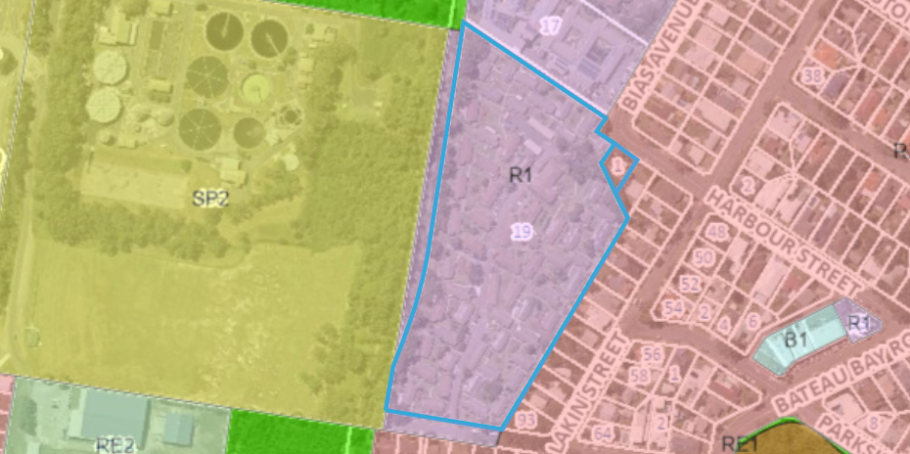

Above: Zoning map under WLEP 2013 and site outlined in blue

The proposed modified development continues to be defined as *Seniors Housing*. Within the R1 zone, seniors housing, and residential flat buildings are permissible development with consent. Within the R2 zone, seniors housing, is permissible development with consent. The other aspects of the development including (café, club room, pool, cinema, hair salon/day spa, gym, consulting/meeting rooms, multi-purpose space and chapel) are all ancillary uses subservient to the primary purpose for seniors housing. The modified development remains permissible within the R1 and R2 zoning of the site and consistent with the objectives for each zone.

*General Controls and Development Standards (Part 2, 4, 5 and 6)*

The WLEP 2013 also contains controls relating to development standards, miscellaneous provisions and local provisions. The controls relevant to the proposal are considered in **Table 5** below.

**Table 5: Consideration of the LEP Controls**

|  |  |  |  |
| --- | --- | --- | --- |
| **Control** | **Requirement** | **Proposal** | **Comply** |
| Height of buildings  (Cl 4.3(2)) | No specified height limit under Clause 4.3 (and the Height of Buildings Map) under the WLEP. | The modified proposal has been designed to meet the requirements of the various SEPPs which override the LEP. | N/A |
| FSR  (Cl 4.4(2)) | No specified maximum FSR applying to the site under Clause 4.4 (and the Floor Space Ratio Map) of WLEP. | The proposal has been designed to meet the FSR requirements under SEPP HSPD. | N/A |
| Heritage conservation  (Cl 5.10) | This clause requires consideration of both European and Aboriginal Heritage | The subject site is not in proximity to any European heritage items or heritage conservation areas. The modified proposal is not subject to any greater or any different land disturbance therefore the original aboriginal heritage assessment is sufficient. There is no modification to the originally imposed ‘unexpected finds’ condition. | Yes |
| Flood Planning (Cl. 5.21) | This clause requires that the Consent Authority be satisfied as to certain matters specified under the clause. | Parts of the site are identified as within a flood planning area. Under the original proposal, the applicant prepared a flood report assessing the hazard. There are no increased impacts or new considerations under the clause that apply to the modified proposal. The modified development is considered satisfactory with regards to Clause 5.21(2) (a)-(d). | Yes |
| Acid sulphate soils  (Cl 7.1) | Clause 7.1 requires assessment to be given to development on land that is mapped as being subject to actual or potential acid sulphate soils. The subject site has been identified as containing potential Class 4 and 5. | An Acid Sulphate Soils Management Plan (ASSMP) was prepared for the original approved development. There are no changes with regard to compliance with this clause under the modified proposal. The modified development will be carried out in accordance with the adopted ASSMP. | Yes |
| Essential Services (Cl 7.9) | Clause 7.9 states that development consent must not be granted to a development application unless the consent authority is satisfied that the services that are essential for the development are available or that adequate arrangements have been made to make them available. | The modified development does not alter any assessment against the original compliance with Clause 7.9. Satisfactory servicing will continue to be provided for the modified development. | Yes |
| Flood Plan Risk Management (Cl 7.3) | Development consent must not be granted to development for the following purposes on land to which this clause applies unless the consent authority is satisfied that the development will not, in flood events exceeding the flood planning level, affect the safe occupation of, and evacuation from, the land— (p) seniors housing, | The site is mapped as flood prone land. The PMF flooding extends across the entire site. This clause provides matters for consideration related to flood prone land for sensitive uses.  A Flooding Impact Assessment was provided with the original approved DA. The proposed overland flow and channel works through the development will alter the impacts of the flood across the site.  The modified proposal continues to comply with regard to the clause and the  safe occupation and evacuation of the site in a flood event.  All habitable floor levels continue to be provided above the respective PMF level with safe access and egress in the 1% AEP and PMF flood events available onto the existing public road network at the proposed access locations. | Yes |

The proposal is considered to be consistent with the WLEP 2013.

*Central Coast LEP 2022*

CCLEP 2022 commenced 1 August 2022. The savings provisions applied to this original DA which was lodged prior to the commencement of CCLEP 2022.

Under CCLEP 2022, the site retains its R1 and R2 Residential zonings and Senior’s housing remains permissible with consent. Additionally, the above clauses under WLEP 2013 (with the exception of the flooding clauses) remain generally consistent requirements under CCLEP 2022.

***(b) Provisions of any Proposed Instruments (s4.15 (1)(a)(ii))***

There are several proposed instruments which have been the subject of public consultation under the EP&A Act, however none require specific consideration and discussion in relation to the proposal.

***(c) Provisions of any Development Control Plan (s4.15(1)(a)(iii))***

The following Chapters of *Wyong Development Control Plan 2013* (‘the DCP’) are relevant to this application:

- Chapter 1.2 - Notification of Development Proposals.

- Chapter 2.4 - Multiple Dwelling Residential Development

- Chapter 2.1 - Parking and Access

- Chapter 3.1 - Site Waste Management

- Chapter 3.3 - Floodplain Management

The modified proposal remains generally consistent with the relevant parts of the DCP chapters and there are no further variations proposed. However, the modified plans propose improved compliance with regards to the following DCP planning controls which were varied under the original approval.

* Clause 4.3.3 (Building Lines- Residential Flat Buildings – 3 or more storeys in height) of WDCP Chapter 2.4 (Multiple Dwelling Residential Development) required a 7.5m front setback. Under the original approval, a variation to the (ground floor and first floor) front setback Block 2 to Altona Avenue was supported. The modified plans increase this setback to comply (from 6.64m to 8m).
* Clause 4.4.4 (Bicycle Facilities) under WDCP Chapter 2.4 (Multiple Dwelling Residential Development) required bicycle parking facilities to be provided at a rate of 1 per 3 dwellings. Under the original approval a variation to the bicycle parking was supported for the development at the rate of 1 space/10 dwellings. The modified proposal includes an additional 14 bicycle parking spaces for Stage 1 which although not achieving compliance is an improvement on the original approval (where no bicycle parking was proposed under Stage 1). It is also noted that additional motorcycle parking is included under the modified proposal.
* Clause 6.4.1 (Visual Privacy) under WDCP Chapter 2.4 (Multiple Dwelling Residential Development) required (for buildings up to 4 storeys in height) a minimum of 12m separation distance between habitable rooms. Under the original approval Block 6 required a 23% variation. The modified development has increased the setback to the eastern boundary (the subject of the separation variation) and has increased privacy planting along this boundary in the building setback of Block 6. This is an improvement in the visual amenity and further addresses any potential for overlooking.

The modified proposal remains consistent and compliant with the other relevant parts of the DCP chapters that applied to the original development.

• Central Coast Development Control Plan 2022 (CCDCP 2022)

CCDCP 2022 commenced on 1 August 2022 and the original application predated the operation of *Central Coast Development Control Plan 2022* (CCDCP 2022) and instead Wyong DCP 2013 applied (refer to savings provisions under clause 1.1.4 of Chapter 1.1)

The modified proposal has been assessed against the provisions of the WDCP 2013 and CCDCP 2022. However, there is no significant change in relevant DCP controls for parking or any other matters under CCDCP 2022.

• Contributions Plans

There are no contributions plans relevant to the proposal as contributions were not originally imposed on the consent. This is in accordance with the Ministerial Direction 94E issued on 14 September 2007 by the then Minister for Planning, which excludes the levying of developer contribution charges to any form of Seniors Housing development proposed by a ‘social housing provider’.

The applicant has provided evidence that they are a social housing provider in accordance with this direction and therefore exempt from the payment of developer contributions under any consent to be granted.

***(d) Planning agreements under Section 7.4 of the EP&A Act (s4.15(1)(a)(iiia))***

There have been no planning agreements entered into and there are no draft planning agreements being proposed for the site.

***(e) Provisions of Regulations (s4.15(1)(a)(iv))***

The modification does not affect any specific considerations that warrant discussion under the EPA Regulation 2021.

* + 1. **Section 4.15(1)(b) - Likely Impacts of Development**

The likely impacts of the modified development, including environmental impacts on both the natural and built environments, and social and economic impacts in the locality have been considered. The relevant consideration under the modified proposal have been outlined below.

*Noise and other impacts*

The applicant provided an updated acoustic report for the modified development. The revised report notes that the location of the plant at roof top has not changed from the earlier assessment report under the approved development. In this regard, Section 7.1.1 of the original acoustic assessment for the approved development states *Condenser units for the ILUs and RACFs located centrally on the roof* and subsequently notes *a barrier around each plant area will be required*. The height of the barrier being dependent on the calculations in order to achieve a noise reduction of 10dB to satisfy noise emission requirements. The report concludes that the modification will not alter the potential noise impacts of the approved development.

Council’s Senior Environmental Protection Officer reviewed the acoustic reports and has accepted the findings of the applicant’s report and is of the opinion that there are no additional impacts caused by the proposed amendments. He has advised that there are no additional conditions to be imposed as the original conditions are satisfactory with regard to ensuring that the building materials and ongoing management of the facility will not adversely impact upon the amenity of the surrounding neighbourhood.

Council’s Senior Environmental Protection Officer has also advised that no additional conditions are needed to address impacts of the modified development with regard to light spill, odour, contamination waste, or acid sulphate soils. The modification does not propose to alter the building footprint or excavate in any additional areas beyond the approval. The original conditions imposed with regards to these aspects of the development are to remain unchanged.

*Waste*

An updated waste management plan was provided to address the internal configurations of the buildingsas proposed to be modified. The WMP indicates that although there will be a slight adjustment to overall logistics, the waste management processes across the site will remain fundamentally unchanged from the approved development.

Waste and recyclables from resident’s rooms and other areas will be collected by cleaning staff. Cleaners regularly attend to cleaning both the ILU’s and the ILU floors. A proposed waste storage cupboard in the lobby of Block 6 is for temporary holding of waste and recyclables which will be transferred by a building contractor to Block 5 for storage and collection. Waste and recyclables from the ILU waste rooms will be transported by the contractor from the waste collection area.

*Stormwater*

An updated stormwater management plan confirming that the management of stormwater will not be altered under the proposed modification.

*Built Form and visual impacts*

The modified development includes minor changes to the building envelopes as a result of adjustments to the internal building layouts of buildings 2, 5 and 6 to provide a more efficient building design following detailed services and structural consultant input.

The additional 2 units and reduction GFA has been achieved through redesigning the entries to provide one central entry foyer to each building and though reconfiguration of floor plates in a number of units which improve internal efficiencies. This has also resulted in minor changes to the facades with a reduction in glazed areas.

The modified form of buildings 2 and 5 either maintain the existing approved building line to the adjoining eastern boundary (Lakin Street residents) or increase the setback, lessening the visual impact of the building form. The built form overall retains the existing or a reduced RL height across Stage 1 which lessens the building bulk and provides an improved visual outcome for neighbouring residences.

The applicant prepared a visual impact assessment (VIA) to evaluate whether the modification would result in any altered visual impacts from the approved development. From comparative views around the site, the VIA demonstrates that the modifications in built form are not readily discernible and do not result in any greater visual impacts when compared to the approved development.

*Overall impacts*

In this regard, the application is considered satisfactory and will provide and maintain a high level of residential amenity for future occupants of the development. The application is supported as discussed earlier in the report.

Accordingly, it is considered that the proposed modification will not result in any significant adverse impacts in the locality as outlined above.

* + 1. **Section 4.15(1)(c) - Suitability of the site**

The revised modified proposal is considered suitable for the site as the modified proposal will provide much needed senior specific housing in a suitable and desirable location and the modifications will enhance and improve the approved level of residential amenity. The proposal as modified will continue to provide a quality housing outcome for the site as discussed earlier in the report.

* + 1. **Section 4.15(1)(d) - Public Submissions**

These submissions are considered in Section 4.3 of this report.

* + 1. **Section 4.15(1)(e) - Public interest**

There are no matters contrary to the community or public interest associated with the modified development as proposed.

* 1. **Part 5 of the 2021 EP&A Regulation**

There are a number of matters required to be addressed in an application for modification of development consent pursuant to Division 1, 2 and 3 of Part 5 of the 2021 EP&A Regulation.These matters are considered in **Table 7** below.

**Table 7: Consideration of the Requirements under the Regulation**

|  |  |  |
| --- | --- | --- |
| **Matter** | **Comment** | **Comply** |
| Clause 100 Application for modification of development consent | | | |
| May be made by—  (a)  the owner of the land to which it relates, or  (b)  another person, with the consent of the owner of the land (Cl 98(1)) | The application has been made by another person, with the consent of the owner of the land (Cl 98(1)) | Y |
| NSW Aboriginal Land Council consent required for land owned by a Local Aboriginal Land Council (Cl 98(6)). | The land is not owned by a Local Aboriginal Land Council. | N/A |
| Form approved by Planning Secretary and on portal (Cl 99). | The application has been provided in accordance with the Regulation. | Y |
| Applicant details (Cl 100(1)(a)) | Provided on the NSW Planning Portal (‘the Portal’). | Y |
| Description of the development (Cl 100(1)(b)) | Provided on the Portal and outlined in Section 2 of this Report. | Y |
| Address and title details (Cl 100(1)(c)) | Provided on the Portal and outlined in Section 1 of this Report. | Y |
| Description of the proposed modification (Cl 100(1)(d)) | Provided on the Portal and outlined in Section 2 of this Report. | Y |
| Whether to correct a minor error, mis-description or miscalculation, or  some other effect (Cl 100(1)(e)) | The proposed modification is to modify the original consent under Section 4.55(2) and is not to correct a minor error, misdescription or miscalculation. | N/A |
| Description of the expected impacts of the modification (Cl 100(1)(f)) | There are unlikely to be any significant impacts resulting from the proposed modification given there are no significant changes to the external building form or features. Only minor changes are proposed to improve the functioning and layout of the development and to improve amenity. | Y |
| Undertaking that modified development will remain substantially same as development originally approved (Cl 100(1)(g)) | The modified development will remain substantially the same development as that originally approved. Refer to Section 3.1 of this Report. | Y |
| If accompanied by a Biodiversity development assessment report, the biodiversity credits information (Cl 100(1)(h)) | The original DA was accompanied by BDAR however, the modification does not alter the original credits. The proposed modification will not alter or increase the impact on biodiversity values. | N/A |
| Owner’s consent (Cl 100(1)(i)) | The consent of the owner of the land is provided | Y |
| Whether the application is being made to the Court (under section 4.55) or to the consent authority (under section 4.56) (Cl 100(1)(j)). | This Application is made to the consent authority pursuant to Section 4.55(2) of the EP&A Act. | Y |
| BASIX Certificate (Cl 100(3)) | The proposed modification does involve BASIX development and an updated BASIX Certificate has been provided. | Y |
| Penrith Lakes Development Corporation (Cl 101) | The proposed modification does not Penrith Lakes Development Corporation. | N/A |
| Qualified designer statement for residential apartment development (Cl 102) | The proposed modification does involve residential apartment development and a qualified designer statement has been provided. | Y |
| Mining and petroleum development consents (Cl 102) | The proposed modification does not mining and petroleum development consents. | N/A |
| Notification and exhibition requirements (Cll 105-112) | Refer to Section 4.3 of this report. | Y |
| Notification of concurrence authorities and approval bodies (Cl 109) (to be undertaken by Council) | The modification application has been referred to the relevant concurrence and approval bodies as outlined in Section 4.1 of this Report. | Y |

1. **REFERRALS AND SUBMISSIONS** 
   1. **Agency Referrals and Concurrence**

The modification application is:

* Integrated Development (s4.46)

Accordingly, the modification application was referred to various agencies for their GTA’s as required by the EP&A Act and Clause 109 of the 2021 EP&A Regulation and outlined in **Table 8**. There are no outstanding issues arising from these concurrence and referral requirements as the original GTA’s remain.

**Table 8: Concurrence and Referral Agencies**

|  |  |  |  |
| --- | --- | --- | --- |
| **Agency** | **Concurrence/referral Trigger** | **Comments (Issue, resolution, conditions)** | **Resolved** |
| Concurrence Requirements (s4.13 of EP&A Act) | | | |
| N/A |  |  |  |
| Referral/Consultation Agencies | | | |
| Transport for NSW | Section 2.122 and Schedule 3 of SEPP (Transport and Infrastructure) 2021 applies.  The original consent was for development deemed to be traffic generating development in Schedule 3 due to parking provision exceeding 200 spaces under Column 2. The modification includes 3 additional parking spaces. | The application was referred to Transport for NSW who advised on 17 July 2024: *TfNSW has reviewed the information provided and raises no objection to or requirements for the proposed development as it is considered there will be no significant impact on the nearby classified (State) road network.* | Y |
| Integrated Development (s4.46 of the EP&A Act) | | | |
| NSW Rural Fire Service | The development requires approval from the RFS under S100B - *Rural Fires Act 1997* for a Bush Fire Safety Authority (BFSA) for special fire protection purposes. | No objection is raised subject to the previous General Terms of Approval issued 03.11.22 (which defers to the earlier GTA’s of 25.11.21). A revised BFSA was issued for the modified development and is dated 13 Feb 2024. (RFS Ref. DA20210901003748-S4.55-1). | Y |
| Natural Resource Access Regulator | The development requires a Controlled Activity approval under the *Water Management Act 2000 (s89,90 or 91)* | Additional information was requested on 8 Feb 2024. Following provision of the additional information, no objection was raised to the modification subject to the originally imposed GTA’s. | Y |

* 1. **Council Referrals**

The modification application was referred to various Council officers for technical review as outlined **Table 9.** The outstanding issues raised by Council officers are considered in the Key Issues section of this report.

**Table 9: Consideration of Council Referrals**

|  |  |  |
| --- | --- | --- |
| **Officer** | **Comments** | **Resolved** |
| Traffic & Transport Engineer | No objection on traffic grounds. | Y |
| Senior Environment Protection Officer | No objection subject to original conditions. | Y |
| Architect | No objection subject to modified conditions | Y |
| Waste services | Details regarding waste management were requested and the applicant provided additional information to address the matters raised. | Satisfactory |
| Contributions Officer | The application is exempt from contributions under Section 7.11 or Section 7.12 in accordance with the Ministerial Direction dated 14/9/07. The applicant has provided evidence that they are a social housing provider in accordance with this direction. | Y |
| Ecologist | No objection subject to original conditions. | Y |
| Environmental Health Officer -Food & Health | The Stage 1 works do not involve any food preparation areas which are under stage containing the RACF. | N/A |

* 1. **Notification and Community Consultation**

The proposal was notified in accordance with Wyong DCP Chapter 1.2 from 2 February 2024 until 23 February 2024. A total of 2 unique submissions, were received. The issues raised in these submissions included the following:

* Original proposal did not comply with 2 storey height limit
* Development too bulky and dense - fails on size, bulk, height and density
* Too close to bird habitat sanctuary and waterway that feeds Tuggerah Lakes
* Traffic and Noise pollution grounds
* Unsuitable development with negative environmental impacts
* Original approval made incorrectly as height didn’t comply with Council DCP
* Original approval contrary to the community values and public interest
* Modifications seek to provide:
* Less solar compliance
* More car spaces
* Higher density of residents – an increase of apartments
* Less cross ventilation
* No increase in affordable housing options
* Very low increase in deep soil planting and soft landscaping
* Approved DA is problematic and modifications are problematic as modifications do not alter or offer solutions for the problems with the approved DA but compounding the issues to spoil beautiful suburb.
* Buildings are too high and should not be allowed.

Comment: The original development was approved under the provisions of SEPP (Housing for Seniors or People with a Disability) 2004 and complied with the relevant planning controls for height and density and parking that applied under that SEPP. The modifications do not alter compliance with those original planning controls under the SEPP. The modified development does not worsen compliance with the requirements for solar access, cross ventilation, FSR, landscaping and deep soil planting, parking or provision of affordable housing units.

The modified development does not worsen amenity impacts including visual or acoustic privacy and there are no significantly increased traffic or noise impacts associated with the changes.

The issues raised in the community submissions have been addressed earlier in this report and in the recommended modified conditions of consent where appropriate.

**Applicant’s Community engagement and consultation**

It is noted that the applicant undertook their own community engagement regarding their intention to lodge this Section 4.55 application.

This included:

- A letter box drop to 166 homes in the site’s surrounding streets on 9 November 2023

- A letterbox drop to 88 Nareen Gardens residents on 8 November 2023

- Email sent to 50 neighbours and community members on 8 November 2023

- Email sent to 59 neighbours and community members on 17 November 2023 as a follow up to the community information drop-in session.

- Updated project website with downloadable project fact sheets and display boards. 404 website views between 29 Oct – 27 Nov 2023. The Bateau Bay Community Collective Facebook group has 461 members and posted details about the community information session.

- Newsletter distributed to Nareen Gardens aged care residents, families, employees and volunteers; Uniting home care clients and employees; Uniting Church representatives; External stakeholders such as GP’s, allied health providers, pharmacies and community partners.

- Letter sent to 5 local members of Parliament on 15 Nov 2023

- Community drop-in information session held on from 4pm-7pm on 16 November 2023 at Uniting Nareen Gardens- 29 neighbours and community members attended.

- Resident meeting held on 24 August 2023 and resident drop-in information session held on 16 November 2023 from 2pm-3pm. 28 residents attended.

- Customer services 1800 number and Email address ([ask@uniting.org](mailto:ask@uniting.org)) two enquiries were received during November 2023.

- Resident’s information pack distributed to existing Nareen Gardens residents in late November 2023.

1. **CONCLUSION**

This modification application has been considered in accordance with the requirements of the EP&A Act and the 2021 EP&A Regulation as outlined in this report. Following a thorough assessment of the relevant planning controls, referral comments and issues raised in submissions, it is considered that the application can be supported.

The modifications to buildings 2, 5 and 6 which are part of the approved Stage 1 works are satisfactory with regard to the planning controls and have improved the level of compliance originally approved. It is considered that the modified development is substantially the same development to that originally approved and that the impacts of the changes are minimal. There are no significant or unreasonable changes to the building height or approved boundary setbacks for Buildings 2, 5 and 6 and the development continues to comply with relevant planning controls, even improving compliance in a number of instances.

The modified proposal provides an additional supply of housing and services to support an aging Central Coast population, whilst not compromising the characteristics of the surrounding locality. The proposal includes much needed aged care infrastructure and an expanded and modernised housing choice for older members of the community. The proposal is consistent with the broader strategic planning objectives to provide more aged care housing to meet growing demand in established, well serviced areas with a high level of amenity.

It is considered that the modified proposal is supported subject to the recommended draft conditions at **Attachment A**.

1. **RECOMMENDATION**

It is recommended:

* That the Modification Application DA/882/2021/A for a seniors housing development in stages comprising demolition works, construction of a residential care facility (RACF) with independent living units (ILU’s) with associated on-site support services and communal facilities, car parking, landscaping, and other ancillary works under SEPP (Housing for Seniors or People with a Disability) 2004 at 19 Bias Avenue and 1 Harbour Street Bateau Bay be APPROVED pursuant to Section 4.55(2) of the *Environmental Planning and Assessment Act 1979* subject to the draft conditions of consent attached to this report at Attachment A; and
* Pursuant to Clause 118 of the *Environmental Planning and Assessment Regulation 2021,* a notice of determination is to be prepared by Council following the Panel’s determination of this modification application.

The following attachments are provided:

* Attachment A: Draft Modified Conditions of consent
* Attachment B: Architectural Plans